**SUPPLEMENTAL INFORMATION**

**A Bayesian framework for generalized linear mixed modeling identifies new candidate loci for late-onset Alzheimer’s disease**

Xulong Wang*, Vivek M. Philip*, Guruprasad Ananda†, Charles C. White‡, Ankit Malhotra†, Paul J. Michalski†, Krishna R. Murthy Karuturi†, Sumana R. Chintalapudi*, Casey Acklin*, Michael Sasner*, David A. Bennett§, Philip L. De Jager‡,**, Gareth R. Howell*, Gregory W. Carter*

**SUPPLEMENTAL TABLES**

**Supplemental Table 1 (SupplementalTable1.xls, 33 kb).** Ensembl variant annotations for the top 55 associated variants. Variants commonly mapped to multiple annotations.

**Supplemental Table 2 (SupplementalTable2.xls, 15 kb).** NHGRI GWAS annotations for the top 55 associated variants.

|  |  |  |
| --- | --- | --- |
| Method | Formula | Description |
| 1 | $$β \sim N(μ, σ)$$ $$μ=prior$$ $$σ=prior$$ | * Plug in published values of expected mean ($μ$) and its standard error ($σ$) |
| 2 | $$β \sim N(μ, σ)$$ $$μ \sim N(prior, 1)$$ $$σ \sim {inv}_{gamma}(prior, 1)$$ | * Model $μ$ by a Gaussian distribution with expected mean the published value * Model $σ$ by an Inverse-Gamma distribution with expected mode the published standard error ($σ$) |
| 3 | $$β \sim N(t*σ, σ)$$ $$t=prior$$ $$σ \sim {inv}_{gamma}(2, 1)$$ | * Plug in published values of standardized expected mean (*t*) * Model $σ$ by an Inverse-Gamma distribution |
| 4 | $$β \sim N(t*σ, σ)$$ $$t \sim N(prior, 1)$$ $$σ \sim {inv}_{gamma}(2, 1)$$ | * Model standardized expected mean ($t$) by a Gaussian distribution with expected mean the published value * Model $σ$ by an Inverse-Gamma distribution |

**Supplemental Table 3.** Strategies for prior information integration.

**SUPPLEMENTAL FIGURES**

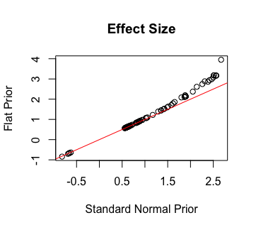

**Supplemental Figure 1.** Effect size estimation of the top 100 variants by ordered categorical models with standard normal (X-axis) or uniform distribution (Y-axis) as priors of variant effect.

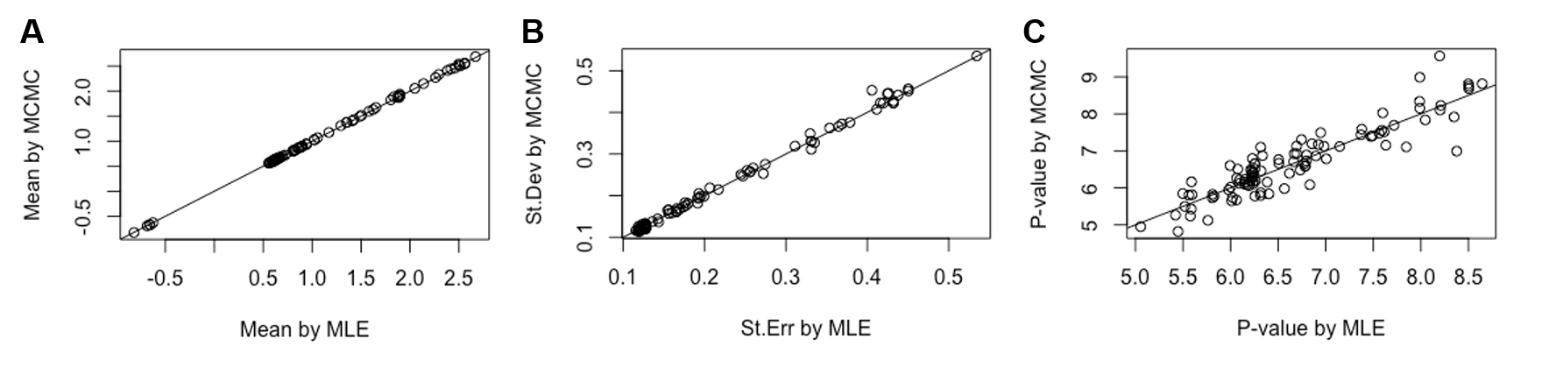

**Supplemental Figure 2.** Variant effects computed by MLE versus MCMC methods. Simulation results showed (A) the two methods report consistent expected means of variants effects; (B) standard error estimation of variant effect mean by MLE and standard derivation estimation of variant effect parameter by MCMC are fairly consistent; and (C) the tail p-values that we proposed are in general consistent with the standard frequentist p-values.

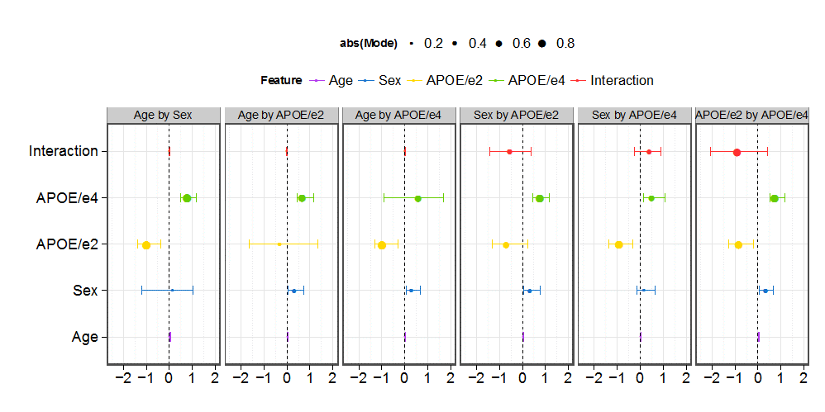

**Supplemental Figure 3.** Interaction tests for covariates estimated by MCMC sampling in *Bayes-GLMM*. No interactions were detected between any pair of covariates (age, sex, APOE/e2, APOE/e4).

**Supplemental Figure 4.** Genome-wide variants in the ADSP WGS cohort stratified by chromosomes. Red bars represent the number of total variants, blue bars represent the number of variants that passed the quality check (Methods), and green bars represent variants that pass the quality check and occur at MAF greater than 0.01.

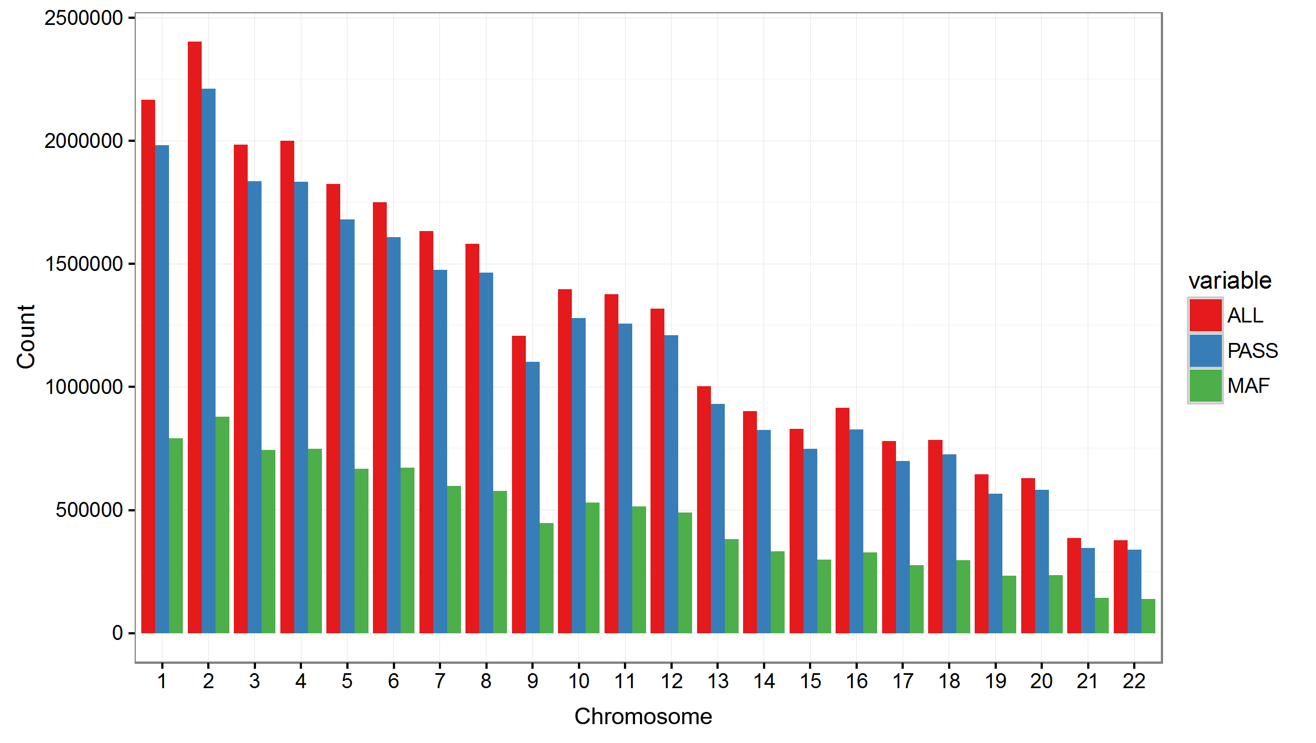

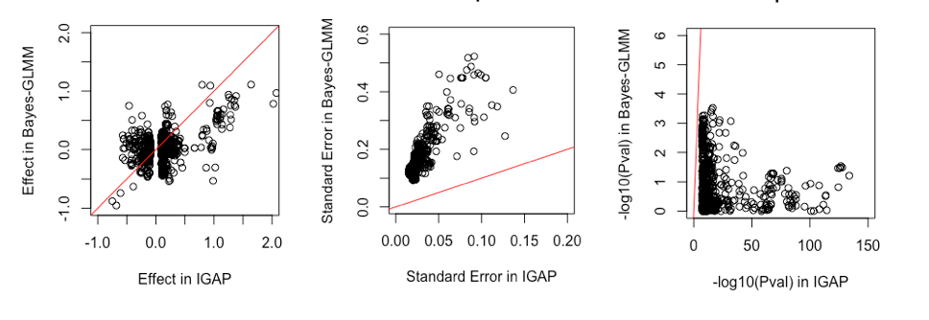

**Supplemental Figure 5.** Effect of the top 1000 IGAP variants in ADSP. IGAP Stage 1 results were plotted in the x-axis. ADSP results, as estimated by *Bayes-GLMM* without integrating prior information, were plotted in the y-axis.



**Supplemental Figure 6.** Posterior P-values (tail probability in –log10 scale, x-axis) versus prior P-values in IGAP (y-axis, left) and posterior P-values with no priors (y-axis, right). The four methods as listed in Supplemental Table 3 were used in specifying the priors. (A) Method 1 resulted in IGAP priors dominating posterior P-values (left) that did not reflect the results without priors (right). (B) Method 2 led to posterior influences dominated by ADSP data (right) that did not match IGAP results (left). (C,D) Methods 3 and 4 allowed IGAP priors to effectively influence ADSP results. Method 4 was chosen over Method 3 because by modeling the standardized effect size (t) as an independent variable in Method 4, it avoids the influence of variance estimation ($σ$) on effect size estimation (t $σ$* ).

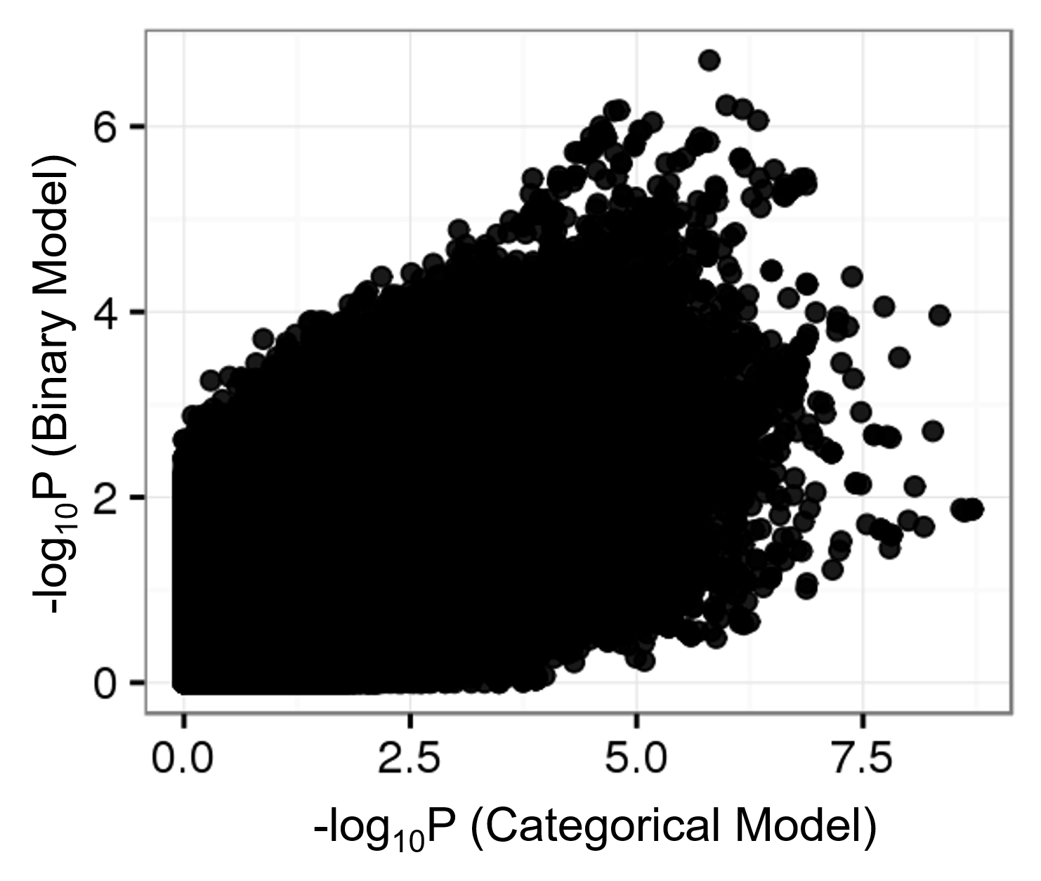

**Supplemental Figure 7.** P-values of the GWAS were distorted by collapsing the ADSP four-level categorical diagnostic variables as binary. *Bayes-GLMM* was used to test 10.3 million genomic variants with MAF greater than 0.01 generalized linear model, using either the four-level categorical variable or a collapsed binary variable to mimic case-control status.

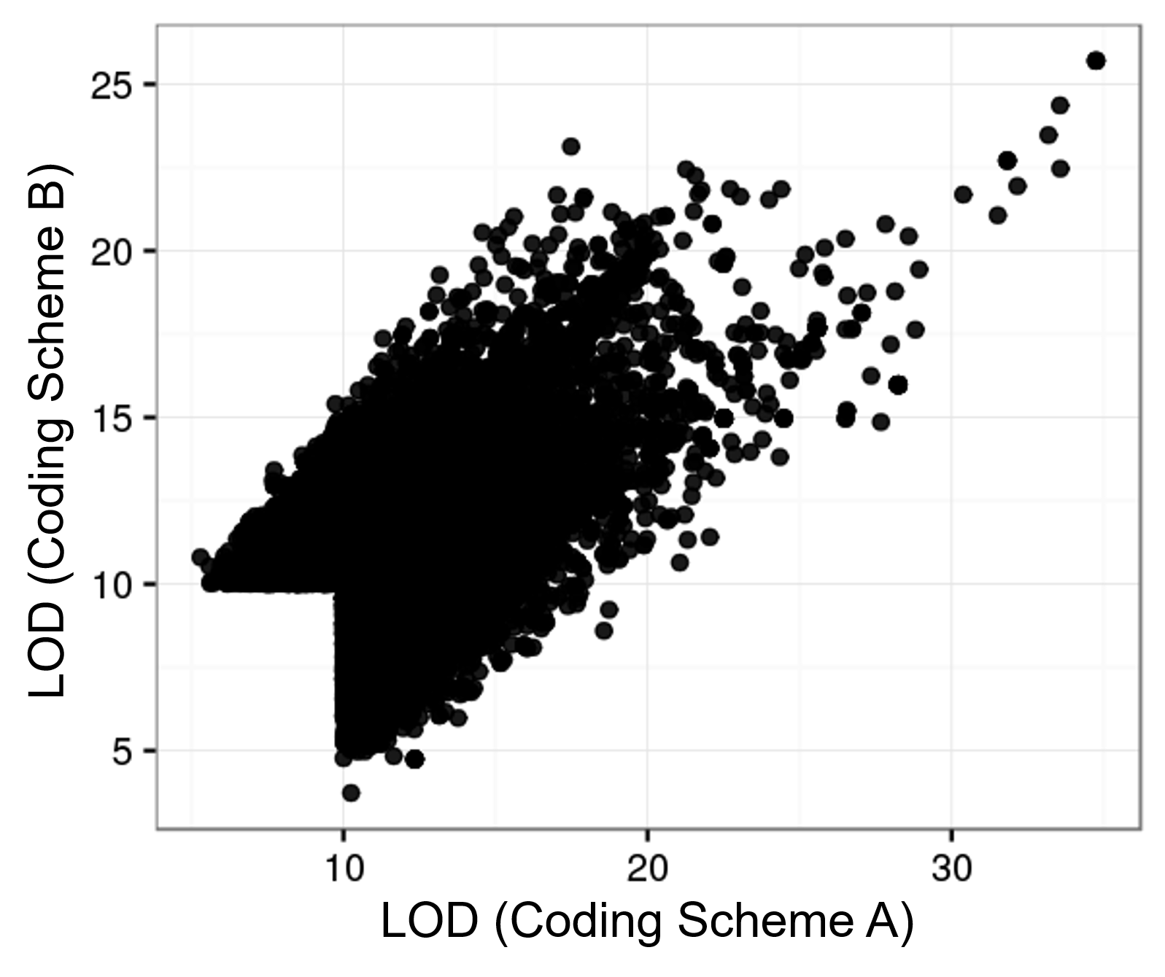

**Supplemental Figure 8.** Results of GWAS using numerical variables shows inconsistency due to numeric coding scheme. The four categorical levels of AD diagnosis in ADSP (no, possible, probable, definite) were transformed to numerical by two rules: Coding Scheme A with 0, 0.25, 0.5, 1; and Coding Scheme B with 0, 0.33, 0.66, 1. Variants with LOD results greater than 10 in either of the two schemes were plotted (23,388 variants). Analysis was performed using a linear mixed model in *QTLRel*, comparing the nested null and full models to estimate the significance of a variant. The full models were the same as described in the text (Materials and Methods: Model Estimations) whereas the null models ignored the variant, *g*, as a linear predictor. In MLE, the null-to-full model improvements was quantified by LOD, which equals log likelihood difference between the full and null models using the MLE estimation of model parameters divided by log(10).

$$LOD= -(\log\left(P\left(data | θ_{p}^{n}\right)\right)-log⁡(P(data|θ_{p}^{f})))/log⁡(10)$$

$θ_{p}^{n}$ and $θ_{p}^{f}$ were the MLE of the parameter spaces under the null and full models, respectively.